**Assignment 11**

**KD1-Indrajeet-86641**

Q1. Write a query that uses a subquery to obtain all orders for the customer named Cisneros. Assume you do not know his customer number (cnum).

🡺 **select cname, orders.cnum, orders.onum from orders, customers**

**where orders.cnum = customers.cnum and customers.cname = 'Cisneros';**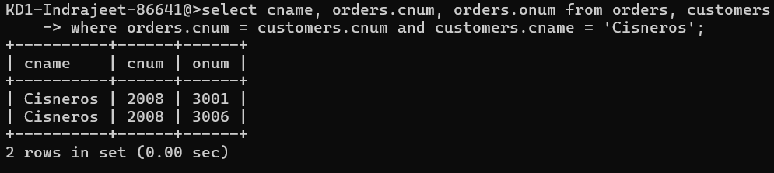

Q2. Write a query that produces the names and ratings of all customers who have above-average orders.

🡺 **select cname, rating from customers, orders where**

**amt > (select avg(amt) from orders) and customers.cnum = orders.cnum;**

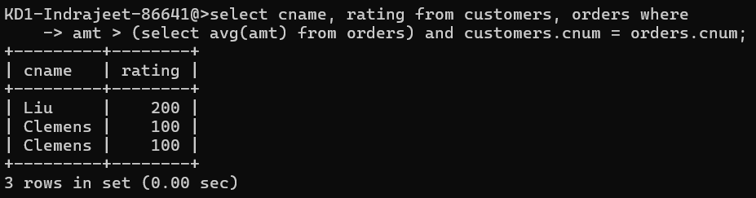

Q3. Write a query that selects the total amount in orders for each salesperson for whom this total is greater than the amount of the largest order in the table.

🡺 **select sum(amt) from orders, salespeople where**

**salespeople.snum = orders.snum group by**

**orders.snum having sum(amt) > (select max(amt) from orders);**

